Practical lab work: Introduction to MongoDB with Node.js
Ablanova Dariya IT-2307
Task A: Insert Multiple Students
// CREATE
const Student = require('./models/Student');

async function createStudents() {
await Student.insertMany([
{ name: 'Dariya', age: 19, major: 'IT', enrolled: true },
{ name: 'Leila', age: 18, major: 'CS', enrolled: false },
{ name: 'Inkar', age: 18, major: 'Physics', enrolled: true },
{ name: 'Abylay', age: 19, major: 'IT', enrolled: false}
]);
console.log("Students added!");
}

createStudents();
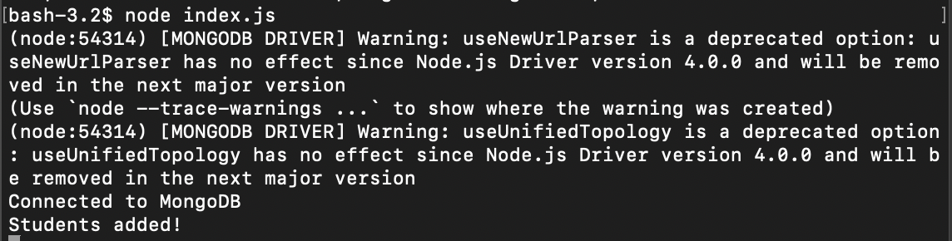
Task B: Query and Log Results
//READ
// Find All
async function findAllStudents() {
try {
const students = await Student.find();
console.log("All Students:", students);
} catch (err) {
console.error("Error retrieving all students:", err);
}
}

//Find One
async function findOneStudentByName(name) {
try {
const student = await Student.findOne({ name: name });
if (student) {
console.log(`Student Found:`, student);
} else {
console.log(`No student found with name: ${name}`);
}
} catch (err) {
console.error("Error retrieving student by name:", err);
}
}

//Filter
async function findEnrolledStudents() {
try {
const students = await Student.find({ enrolled: true });
console.log("Enrolled Students:", students);
} catch (err) {
console.error("Error retrieving enrolled students:", err);
}
}

//Calling functions
(async () => {
await findAllStudents();
await findOneStudentByName('Leila');
await findEnrolledStudents();
})();

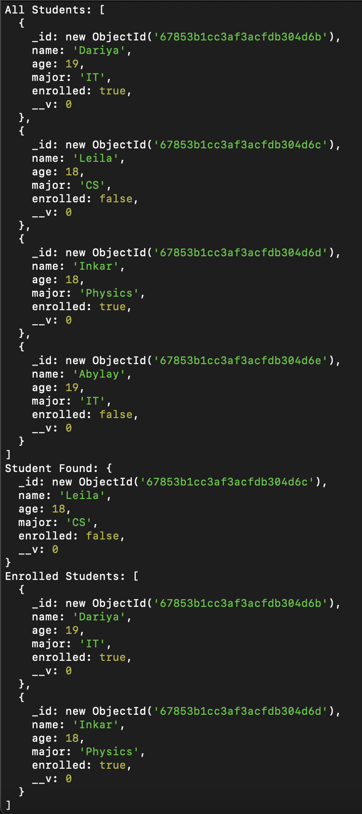
Task C: Update a Student
//UPDATE
async function updateStudent() {
const updatedStudent = await Student.findOneAndUpdate(
{ name: 'Dariya' },
{ age: 18 },
{ new: true }
);
console.log("Updated Student:", updatedStudent);
}
updateStudent();

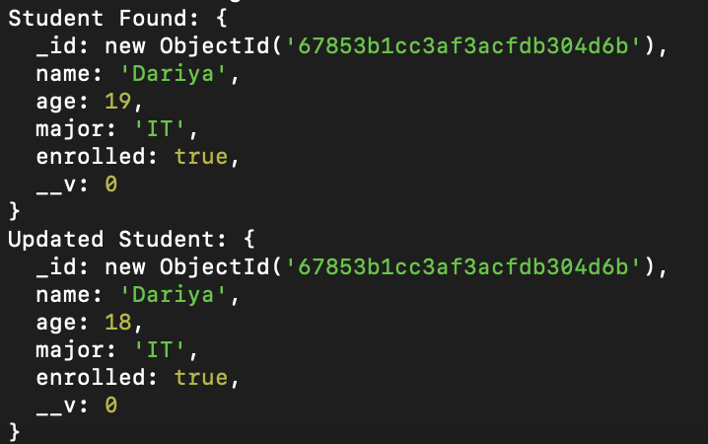
Task D: Delete a Student
// DELETE
async function deleteStudent() {
await Student.deleteOne({ name: 'Leila' });
console.log("Student deleted!");
}

deleteStudent();

